***Joseph Byrne***

***Executive Secretary-Treasurer***

***William Banfield***

***Asst.* to *Executive Secretary-Treasurer***

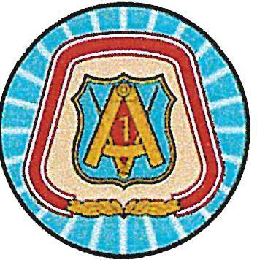

**NASRCC-NY**

***Thomas McKiernan, Chairman***

***Jomo Akono Pedro Galaviz***

***Paul Leo Brian Noteboom***



**Member Assistance Plan (MAP) Guidelines**

**Eligibility**

* Applicant must be a member of North Atlantic Regional Council of Carpenters.
* Member must have been an active member in good standing at time of incident or occurrence.
* A retired member has (1) year of eligibility from date of retirement if they qualify.
* Member should have no outstanding fines or assessments.
* Member should have fulfilled all Membership Union Participation requirements for the previous calendar year.

**Rules**

1. A member is allowed one claim within a 12-month period, per category¹
2. Qualifying member will receive payment of up to $599 per verified claim related to the hardship/disaster.

Reimbursement amount is at the discretion of the Member Assistance Program Committee.

1. Any additional claims per member above the $599 disbursement are subject to Committee approval.
2. Claim must be made within one (1) year of hardship/disaster.
3. An itemized list should be included with supporting documentation, i.e., worker’s compensation or disability award

with dates, doctors’ notes, insurance claims, photos, etc.

**Assistance Categories**

1. **Out of Work (OWL) Dues Assistance:**  the member must be on the OWL at least three (3) months prior to their MAP application date; be available for work; and have a maximum of two (2) declines. Members must comply with the Council’s Job Referral Procedure regarding renewing their OWL status. If a member falls into arrears during the three months he or she is applying for assistance, and is therefore removed from the OWL, he or she may still be eligible for assistance. Funds will be paid in one 6-month payment, paid directly to the respective Local.
2. **Disability Injury Dues Assistance:** After two (2) months of disability or being out of work due to disability or injury, a member becomes eligible for dues reimbursement of up to 12 months. Supporting documentation is required. If approved, funds will be paid in (6) month increments and will be paid directly to the respective Local.
3. **Hardship Disaster Relief:** Assistance due to a catastrophic event, such as fire, flood, etc. or for hardship due to an injury, illness, or death of an immediate family member where a member is experiencing associated hardship. Members are required to provide proof of hardship or catastrophic event. Qualifying members will receive payment of up to $599 per verified claim(s) related to a hardship/disaster.
4. **Guidance Amount:** A member who goes above the normal requirements of Union Participation may be rewarded as the committee deems appropriate.
5. **Critical Shortage – Work out of Area:** see attached.

***All disbursements subject to funds availability and Committee approval. Rules updated January 2022.***